What will we be learning?  Unit R181 – Applying the principles of training – fitness & how it affects skill performance  TOPIC AREA 2 – Principles of training & goal setting in a sporting context | Why this? Why now?  This unit is a compulsory coursework unit for the Sport Science course. This unit is taught in Year 10 as it is the largest of the unit and you will have more time to study the unit in depth. This unit has a practical element too.  Topic area 2 follows on from topic area 1. | Key Words:  Specificity  Progression  Overload  Reversibility  Continuous training  Fartlek training  Interval training  Circuit training  Plyometrics  Resistance training  HIIT  Aerobic  Anaerobic
What will we learn?
TOPIC AREA 2:
  - Principles of training & goal setting in a sporting context
    - SPOR principle, FITT principles, SMART goals

  - Methods of training and their benefits
    - Advantages and disadvantages of the structure of each training method
    - Aerobic exercise
    - Anaerobic exercise
What opportunities are there for wider study?
Sixth form studies
- Cam Tech Sport
- A level PE
Careers/degree courses
- Sports science
- Physiotherapy
- PE teacher
How will I be assessed?
- Set OCR assignments under teacher supervision
CAM NAT – SPORT SCIENCE
UNIT R181 – TOPIC AREA 2

2.1 DEFINITION & APPLICATION OF EACH PRINCIPLE OF TRAINING & GOAL SETTING  2.1.1  - SPOR principle:  - Specificity  - Progression  - Overload  - Reversibility  - FITT principle:  - Frequency  - Intensity  - Time  - Type  - SMART goals:  - Specific  - Measurable  - Achievable  - Realistic  - Time-bound | 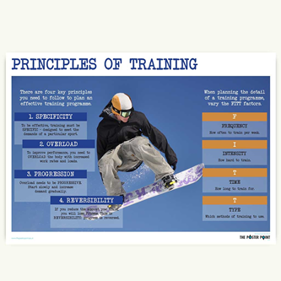
2.2 METHODS OF TRAINING & THEIR BENEFITS  2.2.1  - Advantages & disadvantages of the structure of each training method:  - Continuous training  - Fartlek training  - Interval training  - Circuit training  - Plyometrics  - Weight/resistance training  - HIIT  2.2.2  - Aerobic exercise:  - Intensity  - Duration  - Oxygen consumption  - Methods of training aerobically  2.2.3  - Anaerobic exercise:  - Intensity  - Duration  - Oxygen consumption  - Methods of training aerobically | 